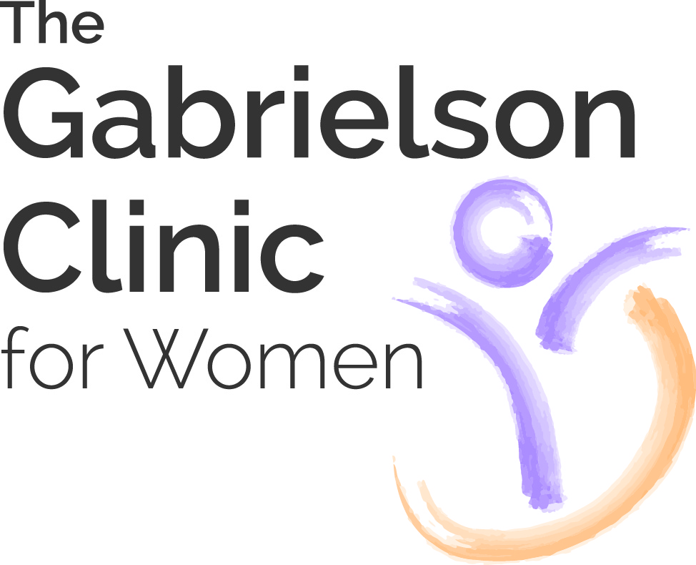

Congratulations on your pregnancy!! Here is some important information you should have…

Daily Diet
- 5-9 Fruits or vegetables (one serving = ½ cup)
- 2-3 Proteins (one service = 4 ounces)
- 4-5 Calcium (one service = 8ounces milk = 4 ounces yogurt = 6 ounces cottage cheese)
- Whole Grains
- 10-12 Glasses of water
- Prenatal vitamin

Foods to avoid
- NO Swordfish, Mackerel, Shark, Tilefish, Marlin, Orange Roughy, Bigeye Tuna, Ahi or Albacore Canned Tuna (Canned tuna is fine as long as it isn’t Albacore). Excess amounts could cause Mercury toxicity. Overall, fish is good for the pregnancy.
- Non-Pasteurized soft cheeses (hardly any are available in the USA)
- Limit 1 serving (12 oz) daily of caffeine (found in coffee, soda, tea, chocolate)
- Limit 2 Services daily of artificial sweeteners
- Lunch meat is fine as long as the place it is purchase from is reputable. If you are unsure or concerned, microwave the meat. (Limit salami, pepperoni & hot dogs due to nitrates)

Behavior
- NO: jacuzzi, tanning beds (spray tans are OK), saunas, hot tubs or steam rooms.
- Don’t lift more than 25 pounds
- Travel in uncomplicated pregnancies: No airplane flights 6 weeks prior to due date. Inform your Doctor of travel dates.
- Moderate level of exercise – Break a sweat but you must be able to talk through the entire workout. Heart rate should not exceed 140 beats per minute.
- No cleaning of cat litter box.

Sex
- Okay if no complications in pregnancy
- Use lubricant
- Orgasms won’t hurt the baby

Hair Care
- Highlighting or dying hair is OK after the first trimester

Paints
- Latex paint only
- Well ventilated rooms

Recreational Activities
- No triathlons or marathons
- No rollercoasters
- No water skiing
- No kickboxing
- No rollerblading, skating, ice skating, snowmobiling
- No horseback riding

Just For You
- Manicures are okay
- Pedicures are okay
- Massages are okay (you may need a letter from your doctor)

Medications you can take for fever, pain or headaches
- Tylenol products only (No Aleve, No Motrin, No Aspirin, No Advil)
- Call your doctor if fever persists

Medications you can take for Congestion (No Zinc)
- Ocean Mist Nasal Spray (NO Afrin)
- Benadryl
- You can take Sudafed, Actifed or Phenylephrine AFTER the 1st Trimester (14 Weeks of pregnancy)

Medications you can take for allergies (No Zinc)
- Benadryl
- Chlor-Trimeton
- Claritin
- Allegra (No D)
- Singulair
- Zyrtec
- You can take Sudafed, Actifed or Phenylephrine AFTER the 1st Trimester (14 Weeks of pregnancy)

Medications you can take for a cough (No Zinc)
- Robitussin DM (Call the doctor if your cough worsens)

Medications you can take for a sore throat (No Zinc)
- Sucrets
- Halls
- Chloreseptic spray

What you can do to treat diarrhea
- Increase oral fluids with Gatorade and water
- Avoid dairy products
- Eat the BRAT diet: B=Bread, Bananas R=Rice A=Applesauce/apples T=Toast/Tea

Medications you can take for heartburn:
- Tums (up to 4)
- Maalox liquid
- Mylanta
- Gaviscon
- Zantac (over the counter)
- Prilosec (over the counter)
- Prevacid

Medications you can use for hemorrhoids
- Preparation H
- Anusol
- Tucks
- Eating Habits: Increase fiber intake. Drink prune juice or pear juice. Increase oral water intake.

Medications you can use for constipation
- Miralax
- Milk of Magnesia (MOM)
- Dulcolax suppositories
- Colace
- Senekot
- Eating Habits: Increase fiber intake. Drink prune juice or pear juice. Increase oral water intake.

Things to do to help with nausea:
- Eat frequent small high carbohydrate meals
- East something before getting out of bed (saltine crackers, ginger snaps)
- Drink Ginger Ale
- Avoid dairy products and citrus
- Wear sea bands / relief bands
- Avoid warm meals
- Avoid fatty foods (red meats, fried food)
- Try taking prenatal vitamin at night
- Unisom and Vitamin B6 – best at night

Dental visits
- Teeth cleaning okay / dental work okay
- X-ray with abdominal shield (only if medically necessary)
- Novocaine and most antibiotics for dental infections are okay
- Ask your doctor if antibiotics are prescribed.

